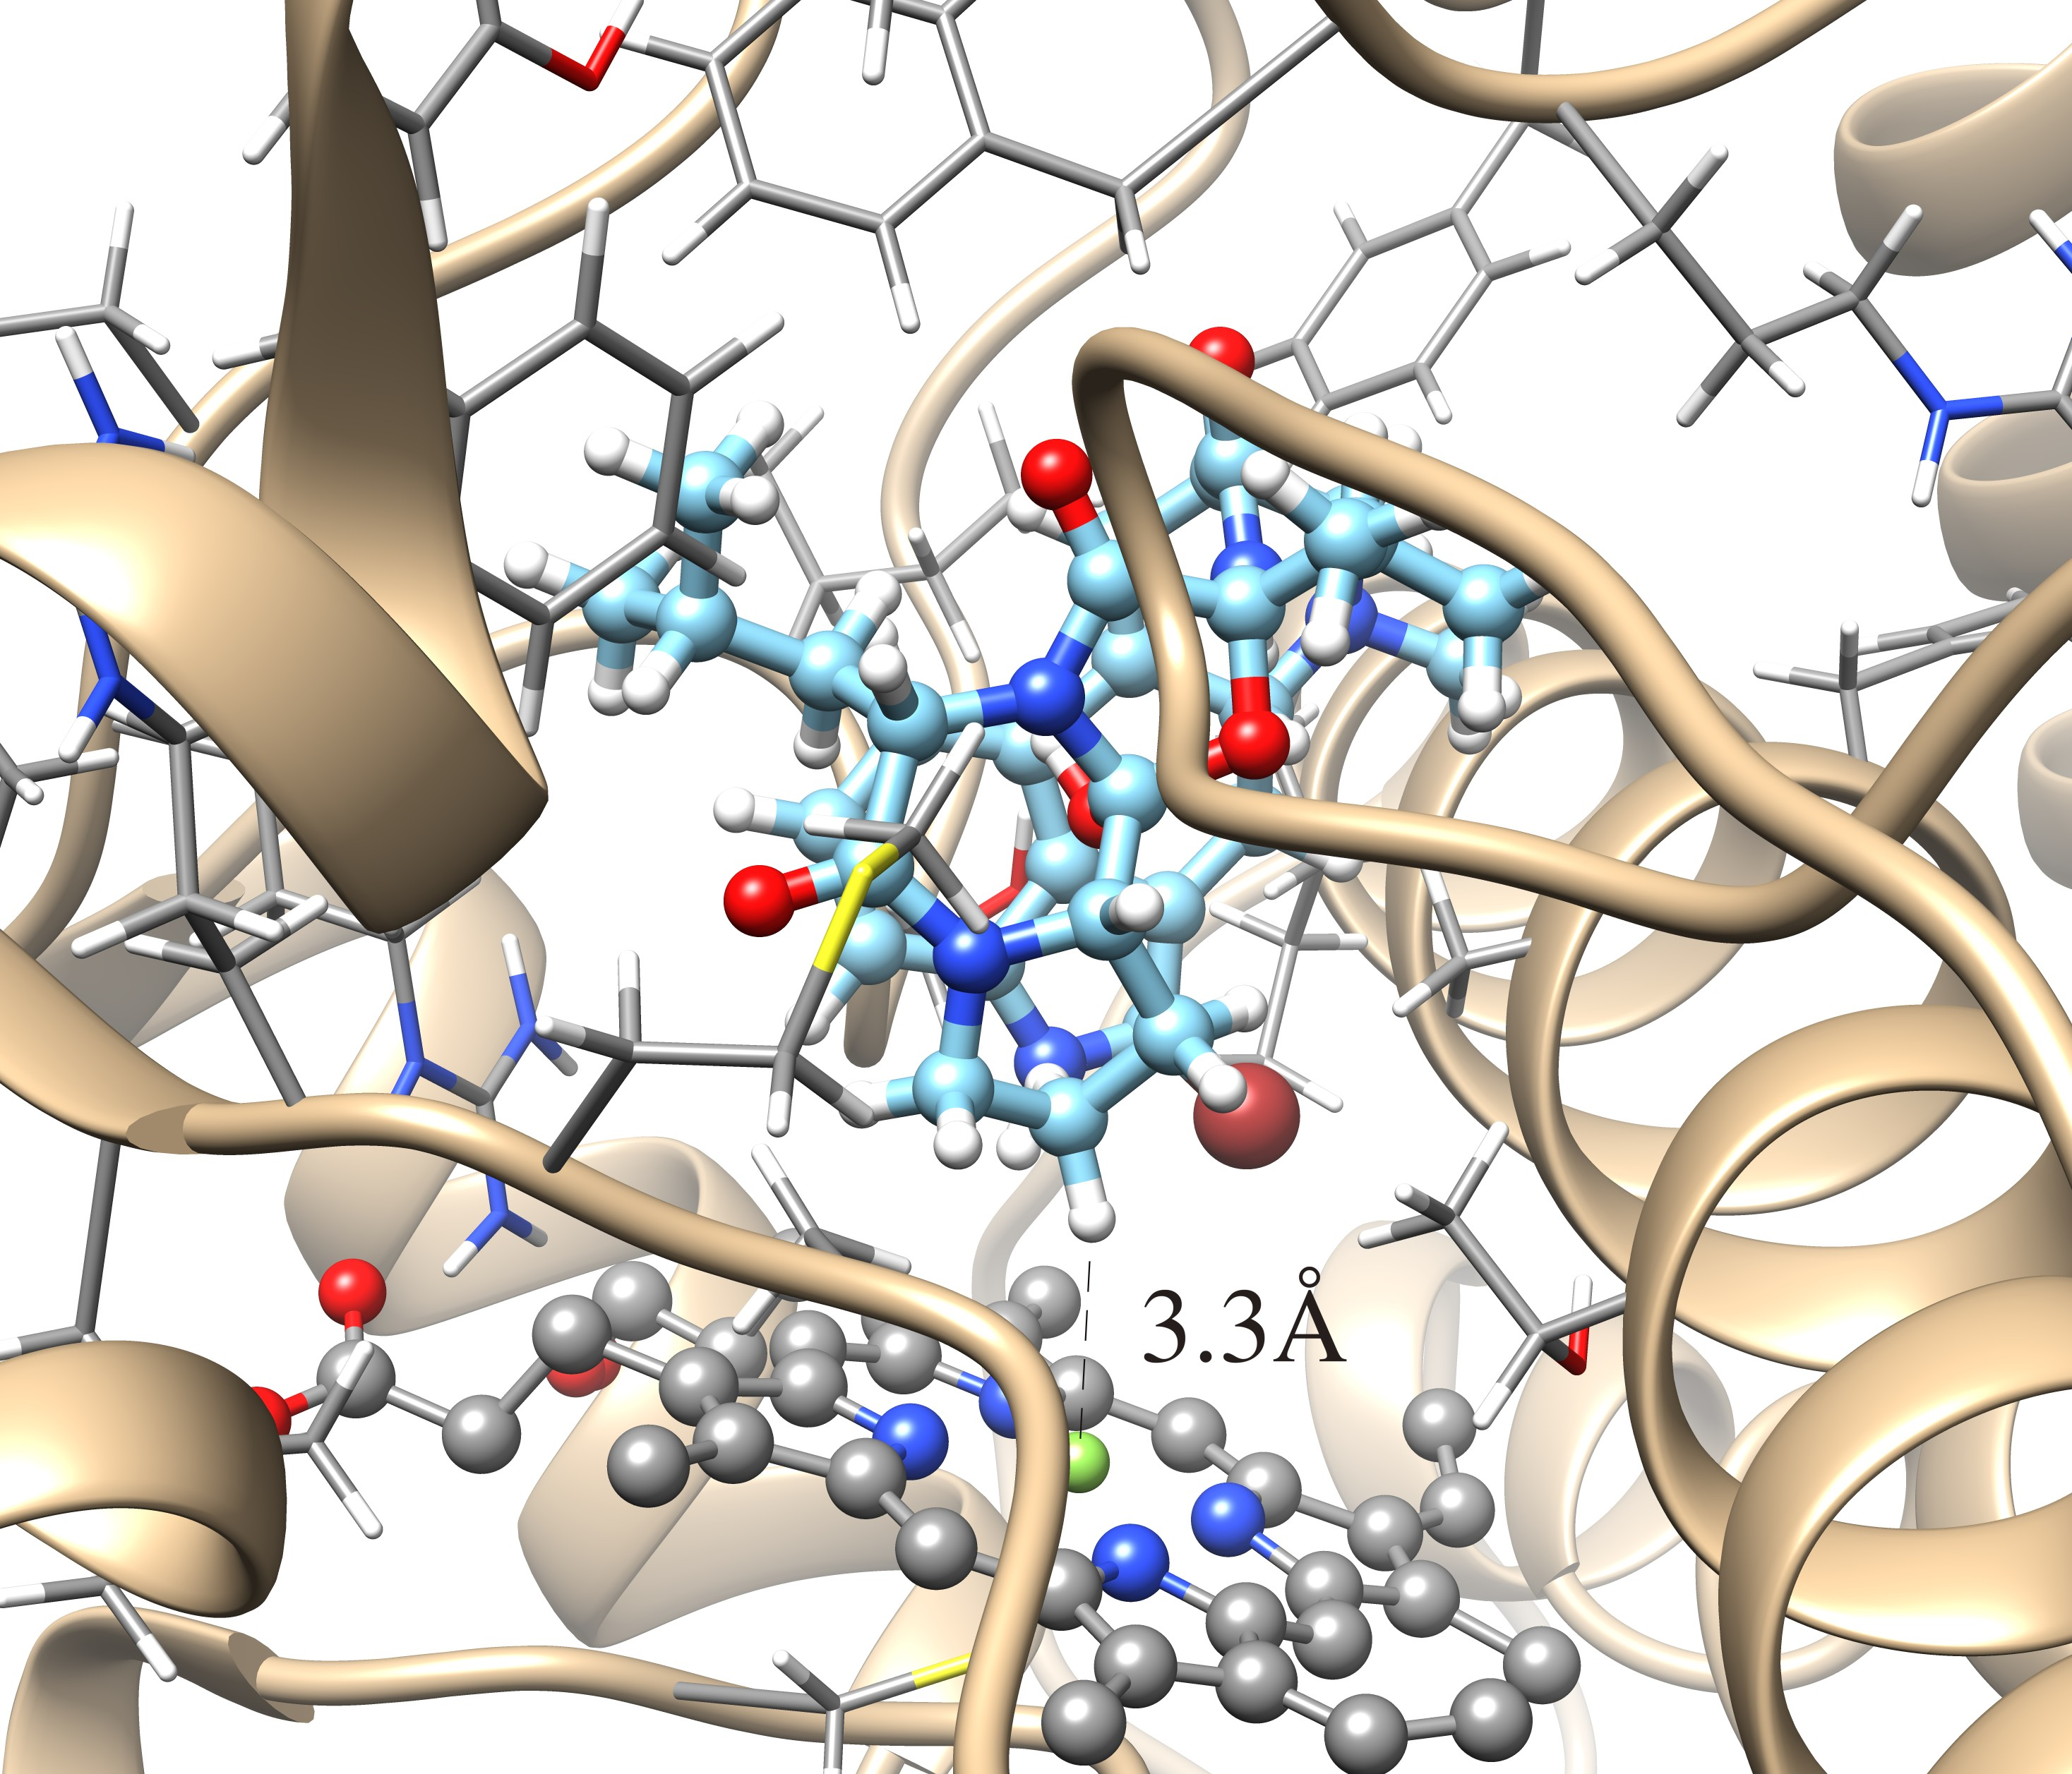

**Supporting Material Figure S1**: Results for docking bromocriptine to the Iron(III) heme oxidation state in the simulation, using the same simulated structure as the other results. The hypothetical productive pose pictured is the top pose from Cluster #2 with a distance of 3.3 Å between the 9’ hydrogen of the cyclic tripeptide moiety and the heme iron (the 9’ carbon-iron distance is 4.2 Å and the 8’ carbon-iron distance is 5.0 Å). The binding free energy of this pose is -9.84 kcal/mol and the highest free energy top pose of the first eight clusters is -9.89 kcal/mol, corresponding to a Kd value of 0.11 μM. It appears that the lysergic acid moiety has rotated into the pocket (behind the cyclic tripeptide in the Figure) near the catalytic center of the protein with respect to the productive pose illustrated in Figure 4 from docking to the Iron(II) heme oxidation state. The top pose of cluster #1 shows the bromocriptine substrate positioned for hypothetical hydroxylation of the valine side chain of the cyclic tripeptide, a product not observed for CYP-mediated bromocriptine metabolism.

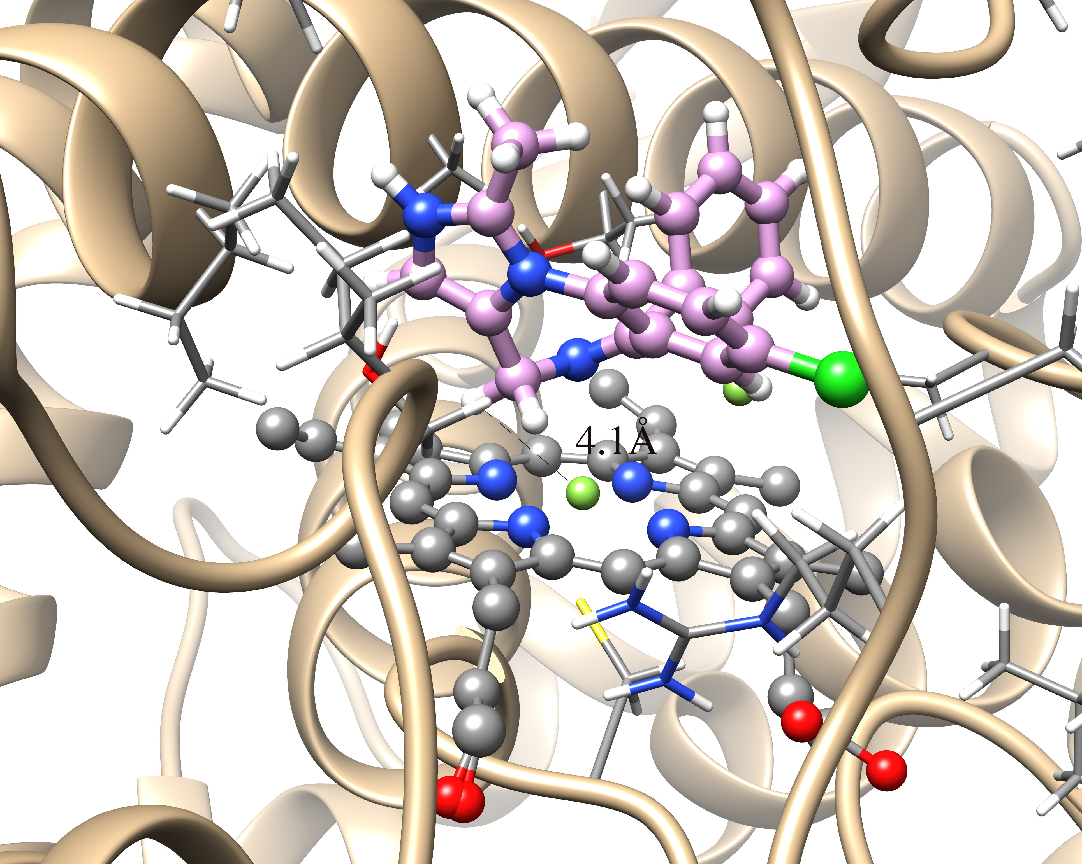

**Supporting Material Figure S2** – A hypothetical productive pose for 4-hydroxylation of midazolam from the top pose of cluster #4 from docking to the single simulated structure in the Iron(III) heme oxidation state. A distance of 4.1 Å between a 4 carbon hydrogen of midazolam and the heme is pictured (the carbon-iron distance is 4.5 Å). Top clustered pose #11 appears to consistent with the 1’-hydroxylation of midazolam, below the cutoff of the first eight clusters but only 0.7 kcal/mol higher in free energy than the top pose of cluster #4 (see Table 2 in the main text).

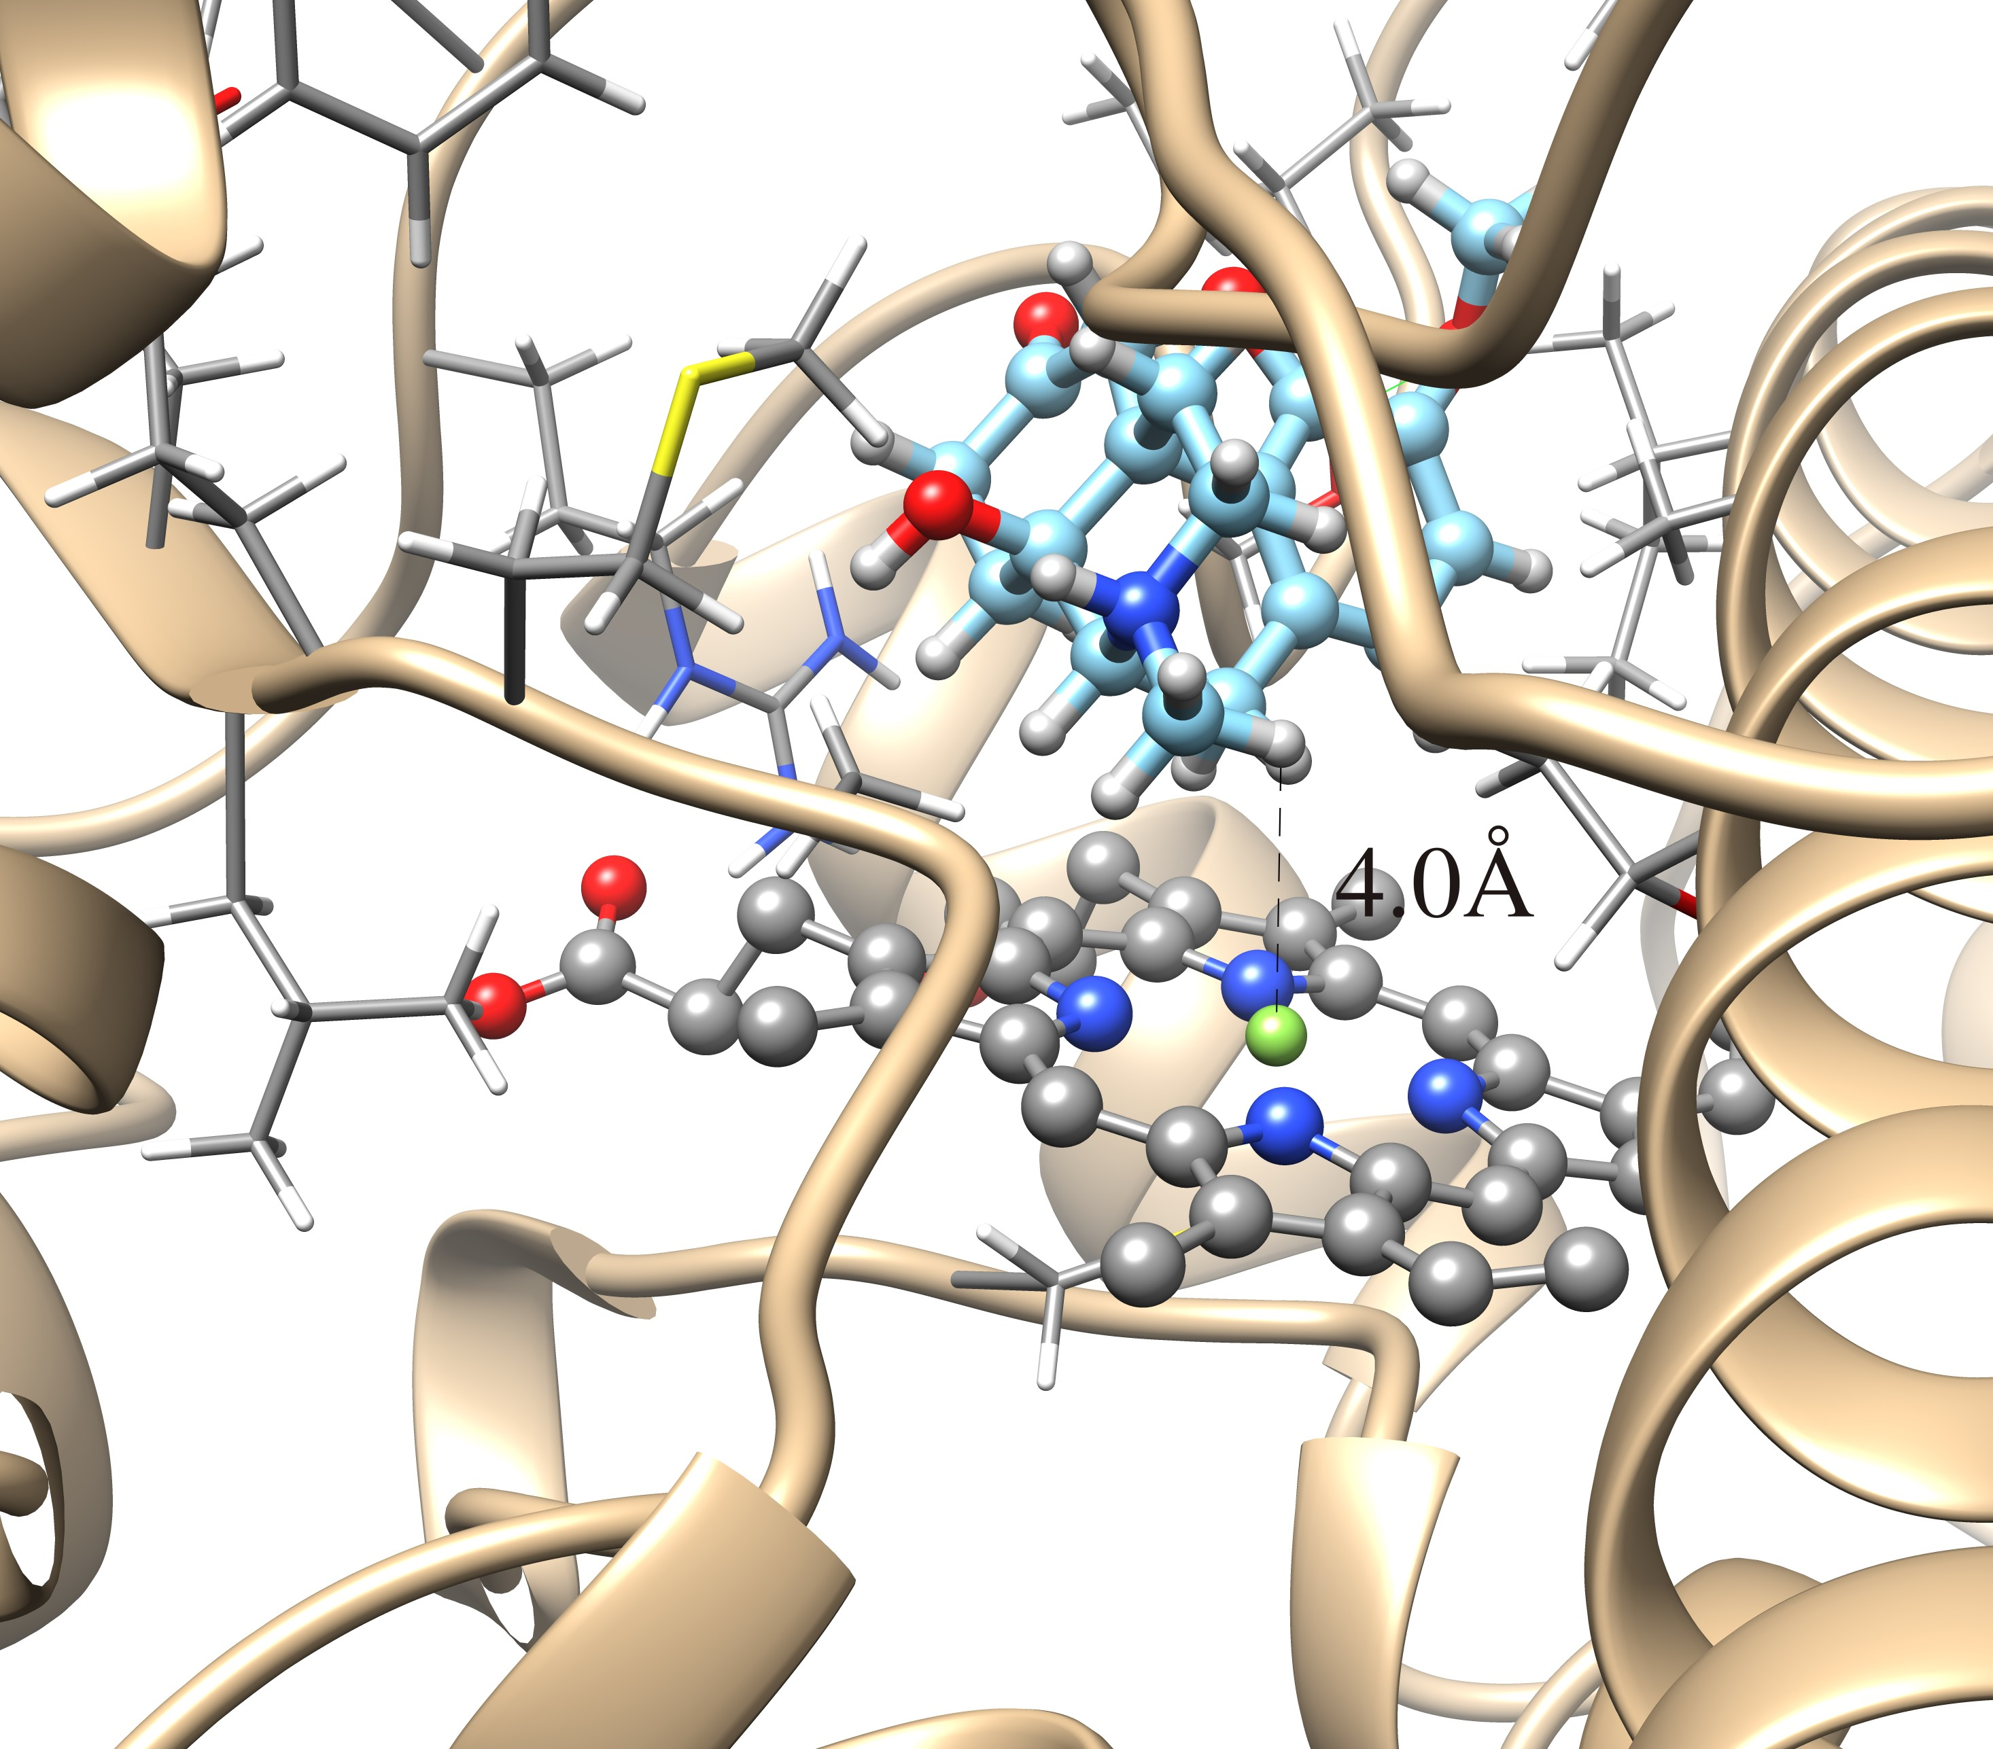

**Supporting Material Figure S3** – A hypothetical productive pose for the N-demethylation of oxycodone from the top pose of cluster #1 from docking to the single simulated structure in the Iron(III) heme oxidation state. A distance of 4.0 Å between one of the methyl hydrogens and the heme is pictured (the carbon-iron distance is 4.5 Å). Top pose of cluster #3 appears to be consistent with the O-demethylation of oxycodone to oxymorphone, an oxidation only observed as a significant product for the metabolism of oxycodone by CYP2D6.

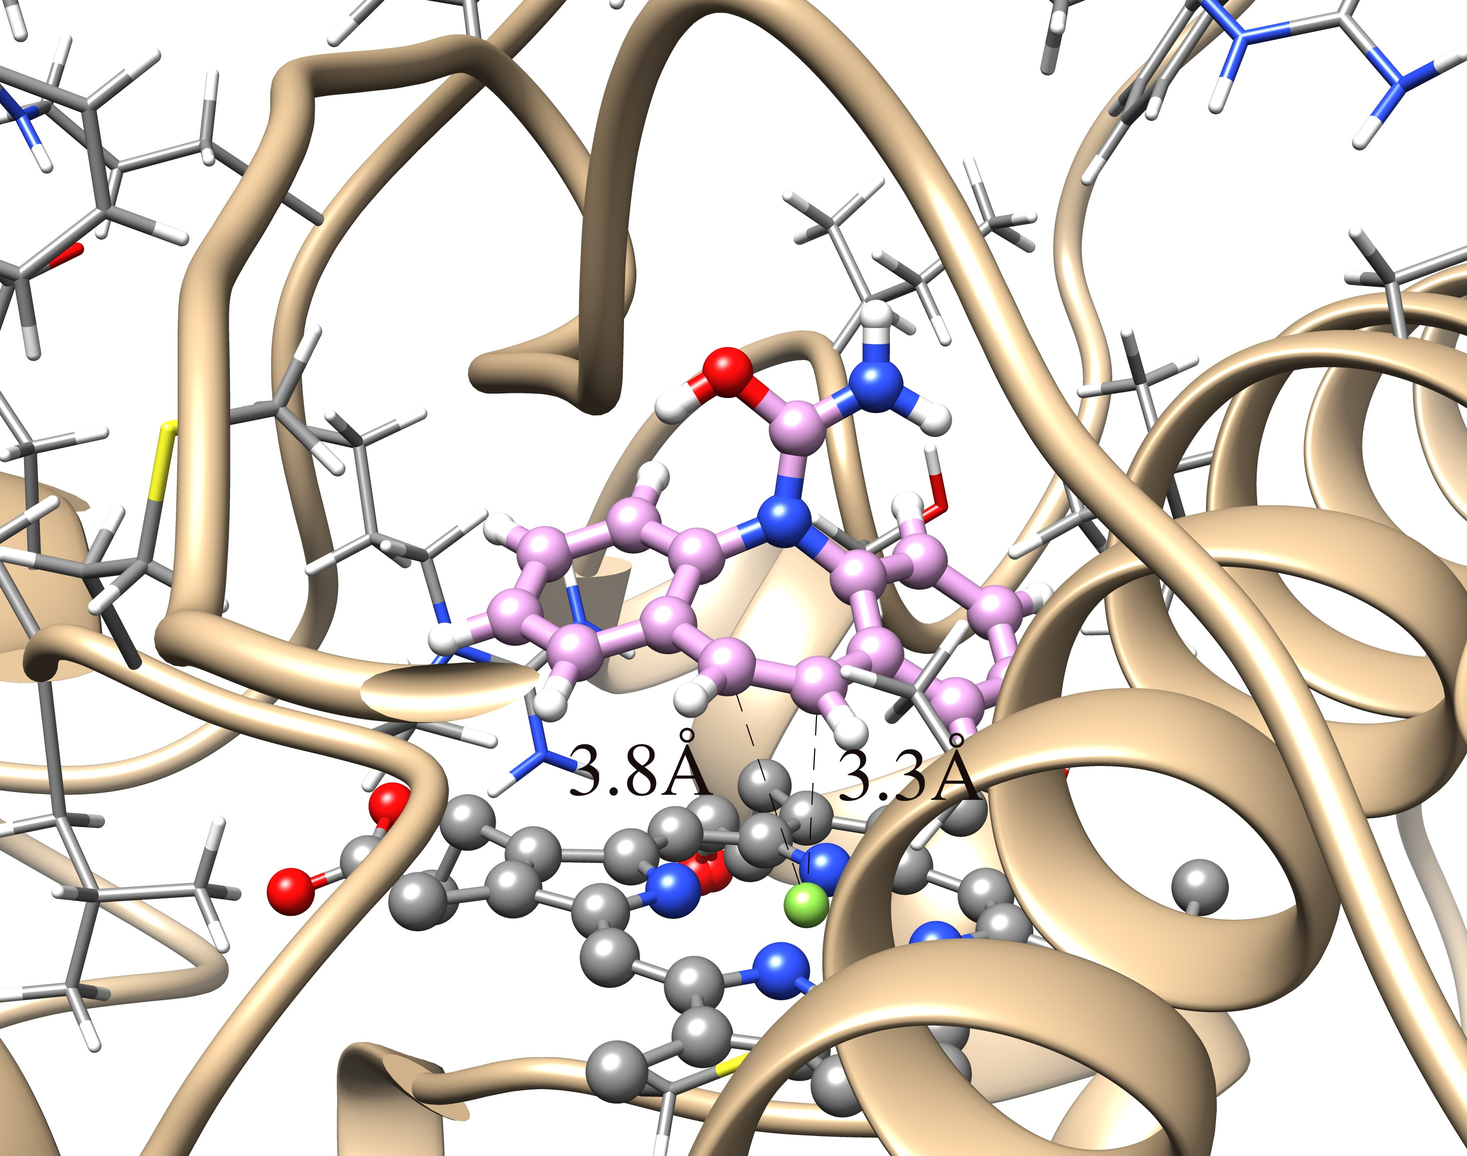

**Supporting Material Figure S4 –** A hypothetical productive binding mode for the 10,11-epoxidation of carbamazepine in the top pose of cluster #1 from docking to the single simulated structure in the Iron(III) heme oxidation state. The 10 and 11 carbons are positioned at a distance of 3.8 Å and 3.3 Å, respectively. The substrate is positioned with the hydrogens of these 10 and 11 carbons almost parallel to the heme porphyrin ring plane, with greater exposure of these carbons to the catalytic center.

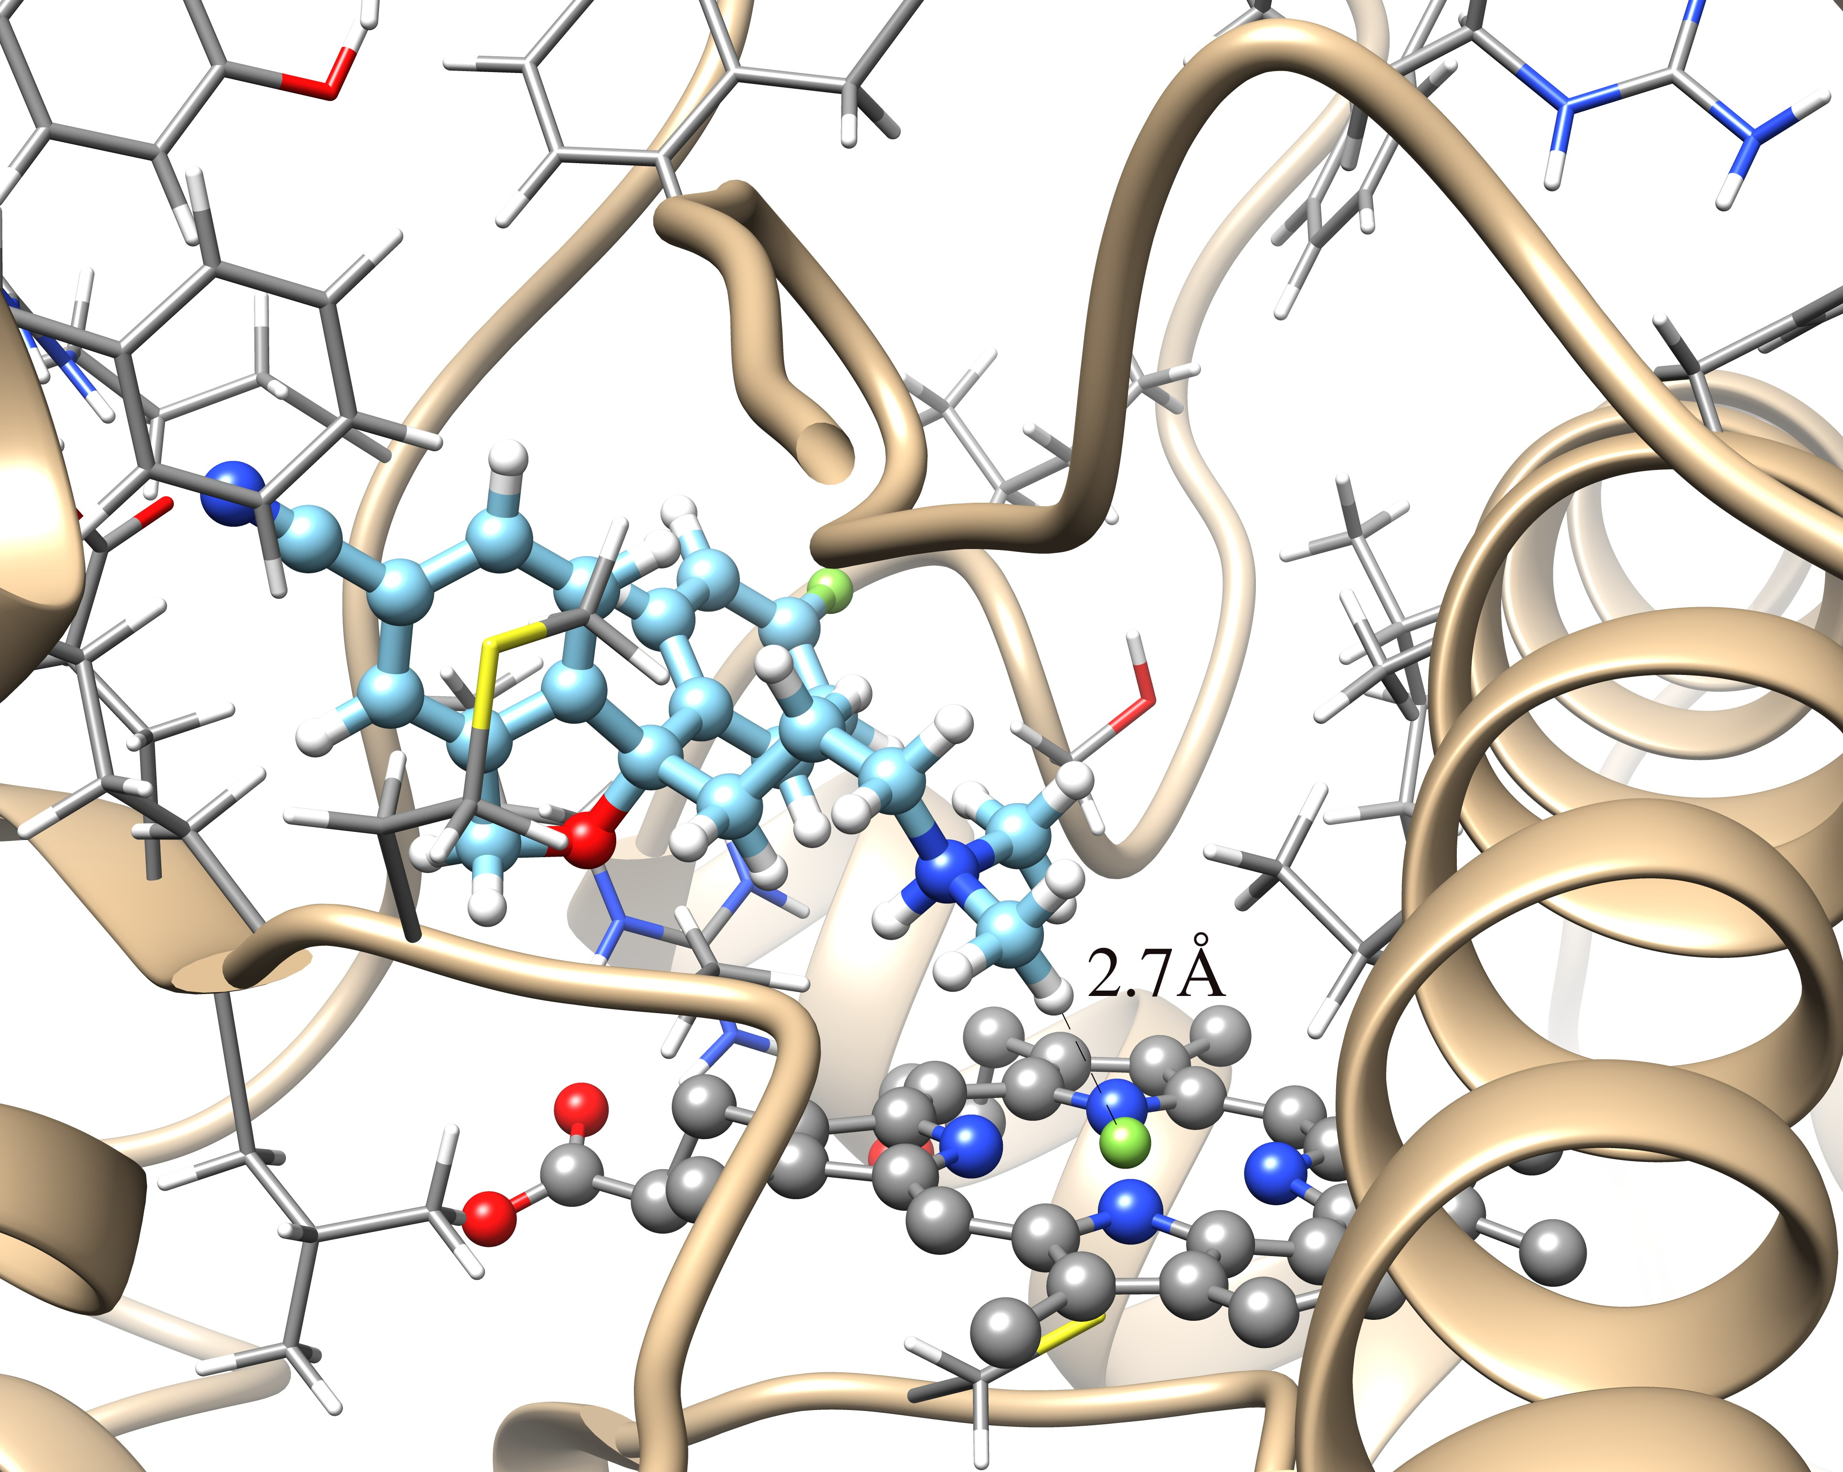

**Supporting Material Figure S5 –** A hypothetical productive binding mode for the N-demethylation of escitalopram in the top pose of cluster #1 from docking to the single simulated structure in the Iron(III) heme oxidation state. The methyl hydrogen is 2.7 Å from the iron with a carbon-iron distance of 3.7 Å.

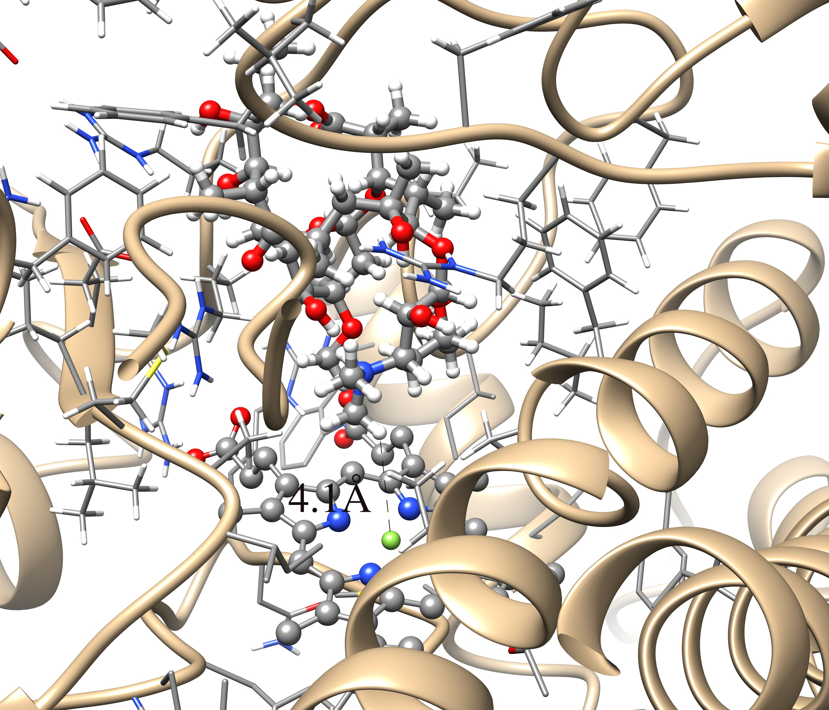

**Supporting Material Figure S6 –** A hypothetical productive binding mode for the N-demethylation of erythromycin in the top pose of cluster #2 from docking to the simulated structure after 300 ns of Accelerated MD in the Iron(II) heme oxidation state. This is the only illustration that is not from docking results using the simulated structure after 50 ns of aMD, because the erythromycin was the only ligand that did not fit in the active site in that structure. The top pose of the first cluster here is very similar to the orientation of erythromycin here, but the ligand is too far from the heme center to be considered productive. In the pose from cluster #2 illustrated here, the methyl hydrogen is 4.1 Å from the iron with a carbon-iron distance of 4.8 Å. The Arg212 amino acid side chain appears to stabilize the positioning of erythromycin through two hydrogen-bond donor (amine and amide nitrogen hydrogens) interactions with the ether oxygen within the 14-membered oxacyclotetradecane ring of erythromycin. The best ΔGbinding of the top poses of the first eight clusters is -10.31 kcal/mol, but nothing definite can be concluded from this value due to Type II ligand interactions of erythromycin and also due to the fact that only the very open active site conformations from the simulation can fit erythromycin. Only the first four clusters from the blind docking result here position the ligand in the active site in this 300 ns simulated structure, and the remaining poses have erythromycin bound to the surface of the protein as in Figure 6 from docking to the simulated structure after 50 ns of Accelerated MD. A population shift of active site states towards more open conformations may occur upon erythromycin binding, consistent with the concept of conformational selection.